Prime, ATS, AMBA, APSE Hotfix upgrade steps

Contents

Uninstalling Prime 2

Install Prime hotfix. 4

Upgrade ATS, AMBA, APSE 7

# Uninstalling Prime

Open add remove program. And uninstall previous version.

For hot fix installation for example 2022.4.0 upgrade to 2022.4.2

Select remove.

Click Remove

Click Finish

# Install Prime hotfix.

Run setup.exe as administrator.

# Upgrade ATS, AMBA, APSE

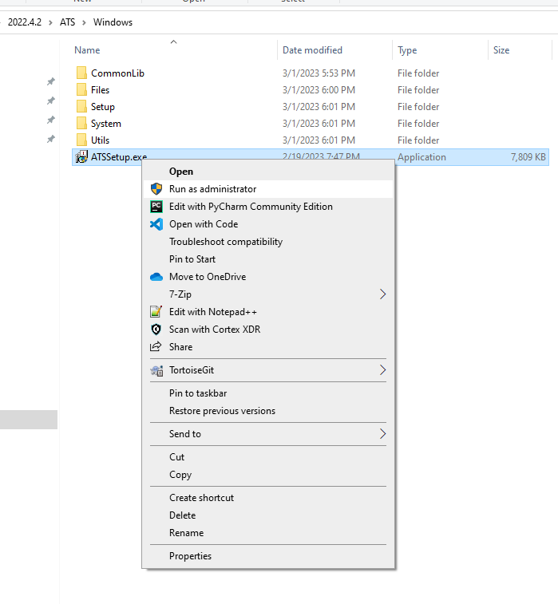

Select option upgrade and instance or multiple instances you want to upgrade.

Continue to click next till installation is completed.